Tiered Proposal Approvals
Specifications/Explanation

- The proposals tab of the NEST Portal now contains the concept of tiered approval limits.
- Users can be set up in the following way:
  - User can approve ALL dollar amounts, no limit
  - User can approve up to a certain dollar amount, limit is set
  - User can NOT approve any proposals, view only/non-approver
- All users will have the ability to Decline, regardless of their approval limit or lack of one.
- Approval limits are set up by NEST.

For example:
- “User A” has a proposal limit of $500. This means the user can view all proposals of ANY dollar amount but can only approve up to $500.00. If a quote is $500.01, the user will NOT be able to approve this. However, user will be able to Decline any proposal of any dollar amount.
- “User B” has a proposal limit of $0. This means the user can view all proposals of ANY dollar amount. However, this user cannot approve ANY proposal of any dollar amount. However, user will be able to Decline any proposal of any dollar amount.
- “User C” has a proposal limit of “NULL”. This means, the user does not have a set limit. This would be a super-user, someone who is allowed to approve ANY proposal for ANY dollar amount with no limit at all. (This user can still decline any proposal.)

If a user has approval rights, and the proposal is within their limit, they will see the normal Approve/Decline options. Screenshot below.
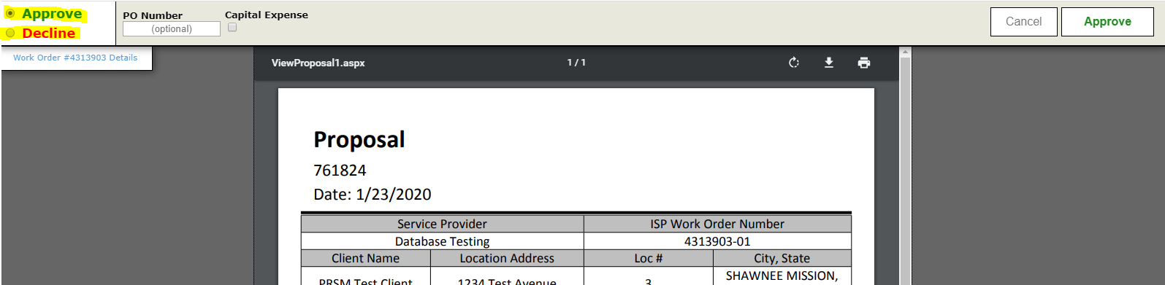

If a user does NOT have approval rights, or the proposal is above their limit, they will NOT see any options for Approve; they can only view the proposal and/or Decline. Screenshot below; notice the empty section to the left, not allowing user to select Approve. Only decline and cancel are available.
