

Client Portal Release Notes
12/31/19

Items

- Work Order Number Hyperlink to Order Details on WO List and Proposals Page
- Grid Height Adjustments
- Schedule Date Logic Update
- Added Cleanup Function to Remove RTF Markup

Item Details

- Work Order Number Hyperlink to Order Details on WO List and Proposals Page

The Work Order number has been turned into a hyperlink to the ‘Order Details’ on the ‘WO List’ and ‘Proposals’ page. The ‘Details’ button was removed in favor of this method. Doing this eliminated a column in the grid which make its more efficient to navigate. This also fixes an issue that was reported where a user would click the ‘Details’ button and it would take them to a different Work Order.

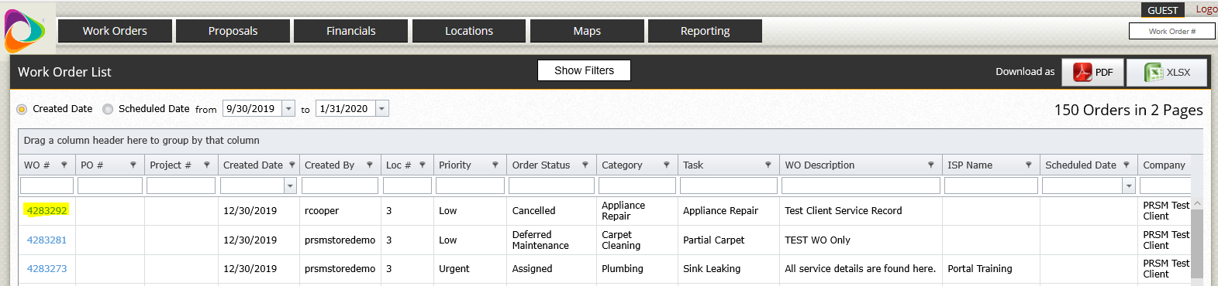

- Grid Height Adjustments

The Grid heights have been adjusted to maximize the number of rows a user can view without scrolling.

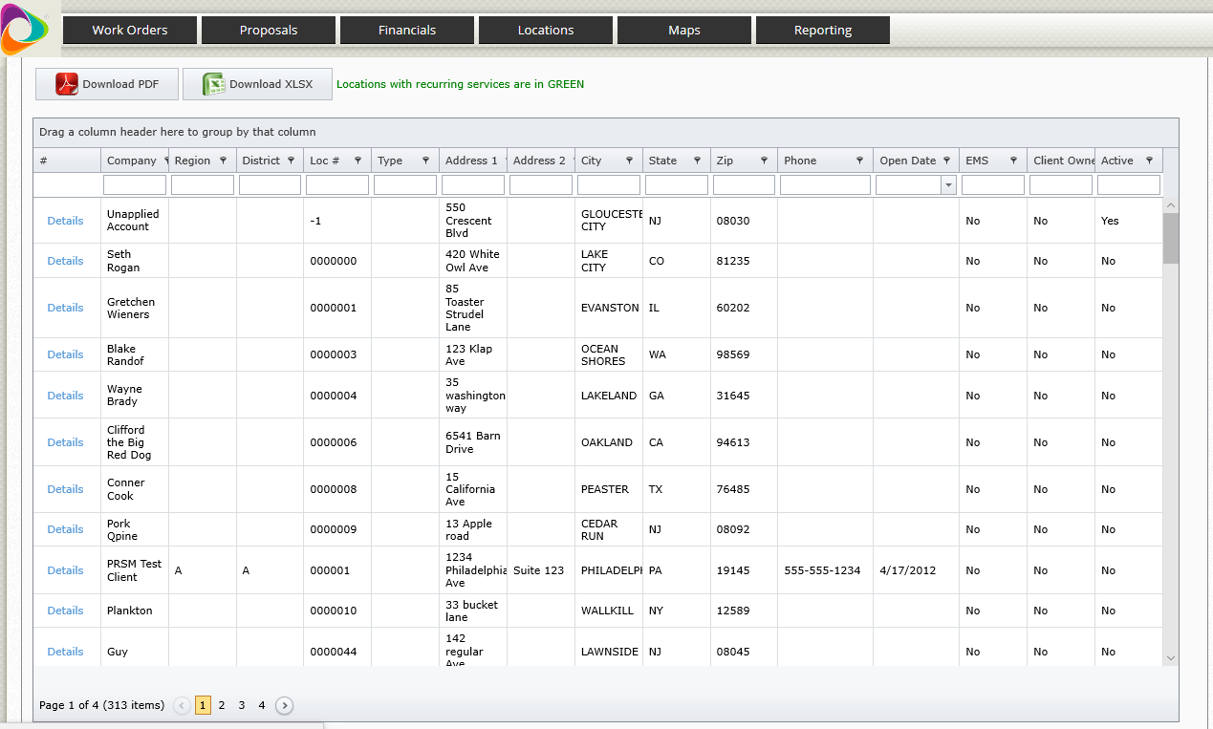

- Schedule Date Logic Update

An update was made to the logic that displays Schedule dates for Work Orders. This addresses an issue that was identified where certain work orders in an Open status that were not displaying correctly.

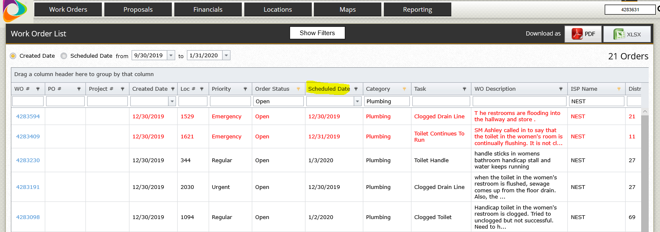

- Added Cleanup Function to Remove RTF Markup

A cleanup function was added that removes odd RTF characters from showing in the ‘WO Description’ (AKA ‘Order Comment’) and ‘Order Notes’ if that is where they were entered. This was done because these odd RTF characters are not supported by the site because they can cause issues. As highlighted in the screenshot below odd characters sometimes go through in place of spaces, commas, etc. in most places this change has been made.

