

Client Portal Release Notes
12/26/18

The following 3 features have been added to the Client Portal and below is a summary of each item.

- Ability to Email a Note
- Column Added to indicate if the Location is Under Warranty
- Mark a Work Order as CapEx from Invoice Approval Screen

Feature Details

- Ability to Email a Note

An enhancement has been added to the “Order Notes” section within the Work Order Details that gives a user the option to email a note to a recipient of their choice.

If the user wants to email the note, the first step is to select the “Email Note” checkbox. Once this is done, the following 3 items appear.

- “Action Required” checkbox – If this option is chosen, the Subject Line in the email that is sent will start with “Action Required”.
- “Email To” – This field can be used if the user wants to manually add an email address to send the note to. This field also auto populates with the email address if the user selects a recipient from the “Pick From a List”. Note that more than 1 email address must be separated by a semicolon.
- “Pick From a List” – When this box is selected, a pre-populated list of recipients will appear that can be selected from. This list will vary depending on the user type (store user vs. non-store user
  - Store Users
    - Store email address where the service is being completed. Display name is the store number (ex. Store 01107)
    - Email address for Service Provider performing the work. Display name is the company name of the Provider.
    - Email address for FBL Maintenance Support. Display name is FBL Support.
  - Non-Store Users
    - Same options as the Store Users but also the following:
      - Display name Judd Hines. Email address is judd.hines@fivebelow.com
      - Display name Danine Jenkins. Email address is danine.jenkins@fivebelow.com
      - Display name Amy Stelmaszyk. Email address is amy.stelmaszyk@fivebelow.com

Once the user has entered their recipients and added the Note, they would hit the “Save” button and the note will be emailed out in addition to showing in the note history at the bottom of the page.

If the user does not select the “Email Note” checkbox on the top of the page, the note will just populate in the note history at the bottom of the page and no email will get sent out.

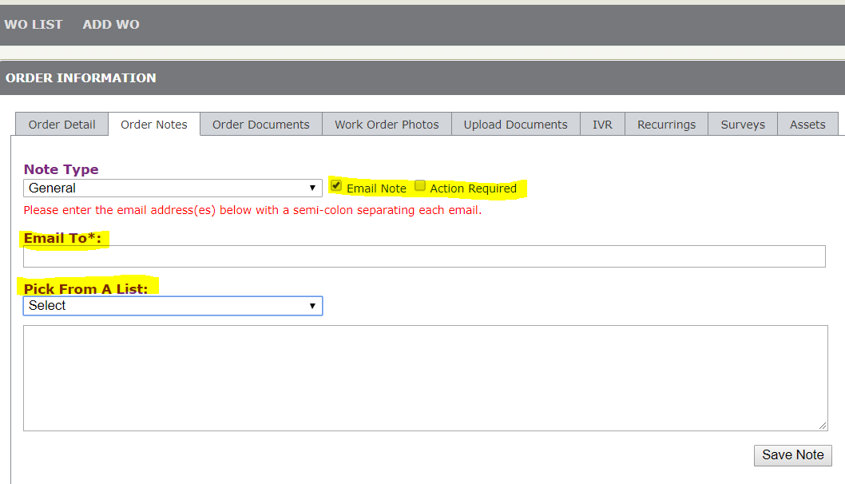
- Column Added to indicate if the Location is Under Warranty

A column has been added to the “WO List”, “In Progress WO”, and “Proposals” page called “Loc Under Warranty”. If the location for the work order has an Open Date within 1 year of the current date, the column will display a “True”. If the location has an Open Date that is not within 1 year of the current date, the column will display a “False”.

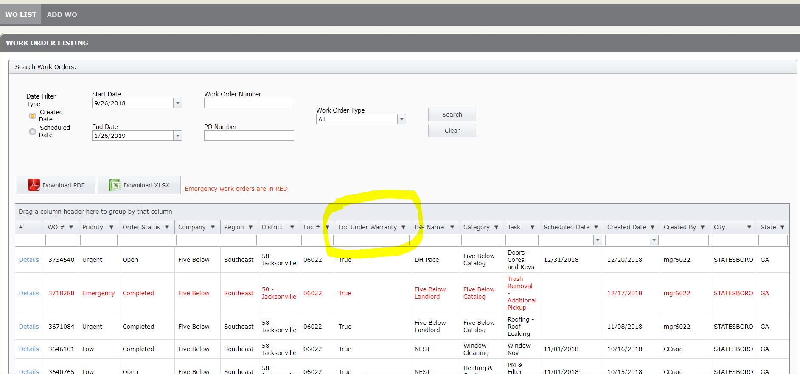

- Mark a Work Order as CapEx from Invoice Approval Screen

An enhancement has been added to the “Invoices” and “Invoice Approval” page of the Client Portal to allow a user to mark a work order as Capital Expense from within the “Invoice Information.”

If the user selects the “CapEx” checkbox and hits save, it will mark the work order as Capital Expense. The user also can uncheck the “CapEx” check box and hit save and this removes the designation.

