

Client Portal Release Notes
5/23/19

Enhancements

- Update to ‘Order Details’ Page to Now Include All Fields from ‘WO List’ & ‘In Progress WO’ Pages
- Moved ‘Loc #’ (Location Number) Grid Column to the Left on ‘WO List’ and ‘In Progress WO’ Pages
- Removal of Word ‘Yes’ Next to ‘Capital Expense’ Checkbox on the ‘Proposal Review’ Page
- Updates to Grid Column Names to Make them Consistent Across the Site.

Enhancement Details

- Update to ‘Order Details’ Page to Now Include All Fields from ‘WO List’ & ‘In Progress WO’ Pages

When a user now selects the ‘Details’ link for a Work Order on the ‘WO List’ and ‘In Progress WO’ page, they will be brought to an updated ‘Order Details’ page. Based on the Users Role (ex. Corporate User vs. Store User), the page now includes all the fields from the ‘WO List’ and ‘In Progress WO’ pages.

The following fields have been added as a Corporate User:

- PO #
- Project #
- GL Code
- Invoice #
- Subtotal
- Tax
- Total
- ISP Name
- Region
- District
- Created By

Users will also notice that the fields have been arranged so that similar information is grouped together to make it easier for the user to consume.

The section ‘Preferred Dates’ was removed and replace with a new section called ‘Accounting’. This new section contains all financial related information.

***Please note that the ‘CapEx’ check box has been moved to the Accounting Section***

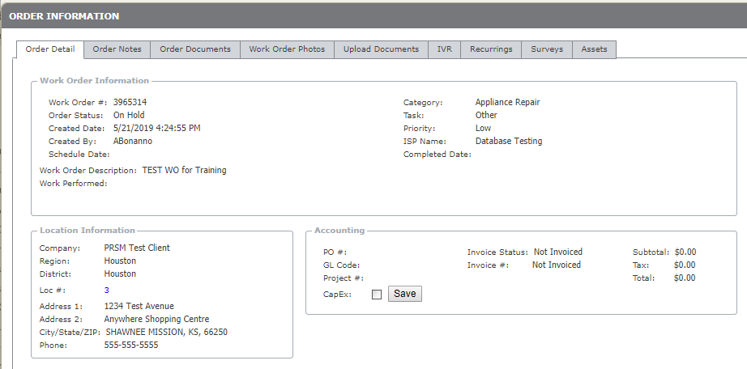

- New Placement for ‘Loc #’ (Location Number) Grid Column on ‘WO List’ and ‘In Progress WO’ Page

The ‘Loc #’ grid column was moved to the right of the ‘Created By’ column on the ‘WO List’ and ‘In Progress WO’ page. This change was made so a user can view it without needing to scroll regardless of their monitor size or resolution.

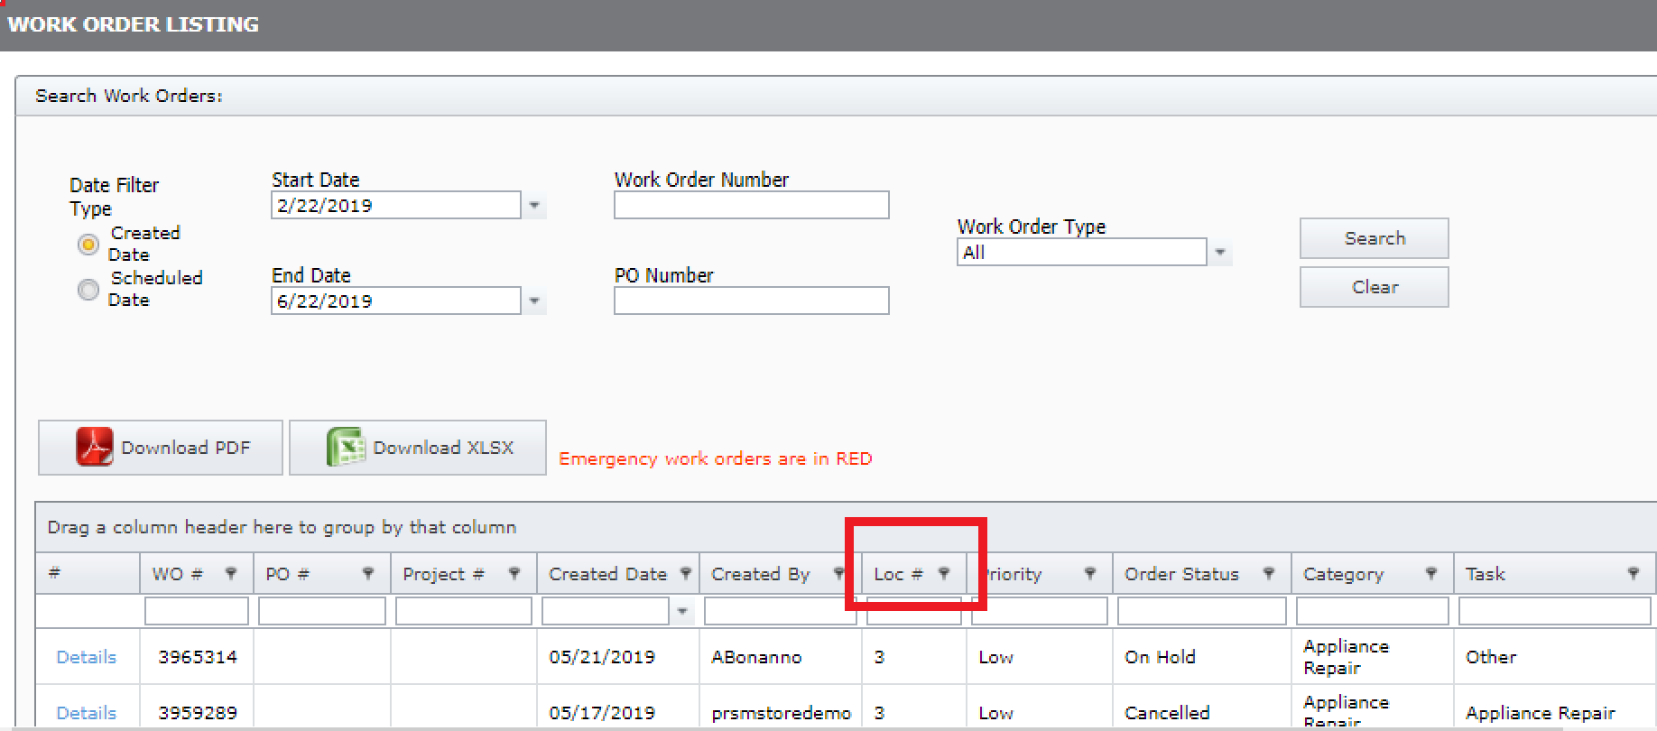

- Removal of Word ‘Yes’ Next to ‘Capital Expense’ Checkbox on the ‘Proposal Review’ Page

The word ‘Yes’ was removed that was to the right of the Capital Expense checkbox on the ‘Proposal Review’ page. This was done to make the user experience the same as when a work order is marked as Capital Expense on the ‘Order Details’ page.

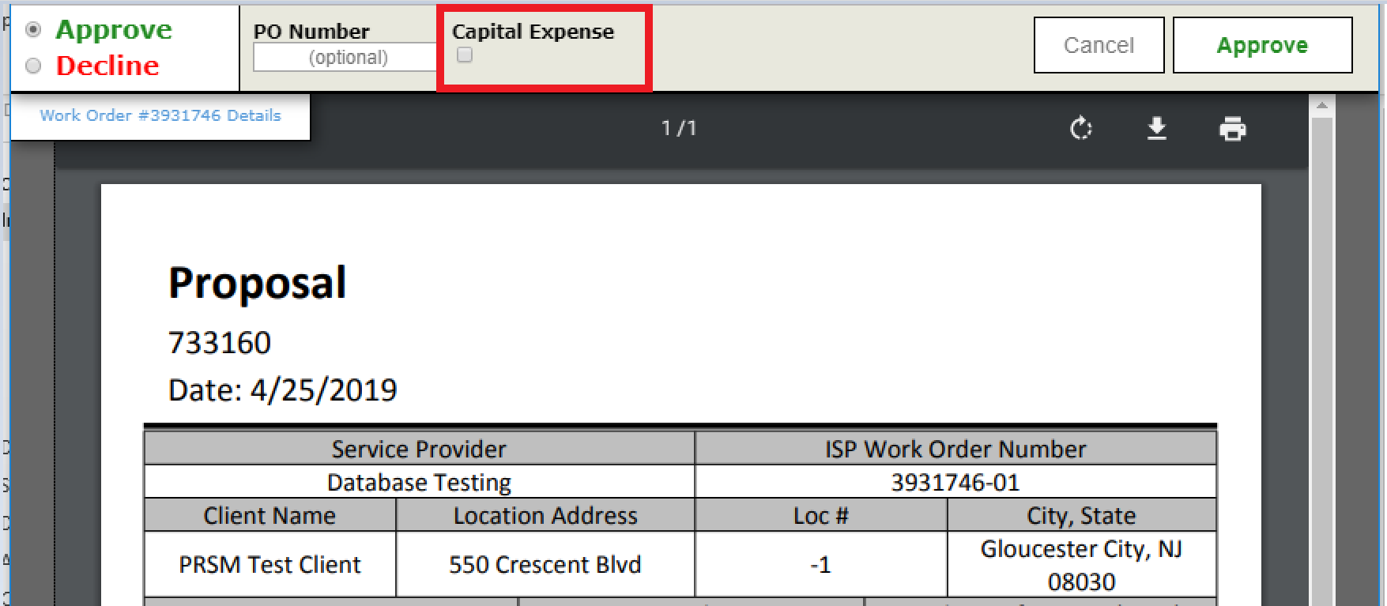

- Updates to Grid Column Names to Make them Consistent Across the Site

We made updates across the website to ensure all grid column names were consistent. An example would be in one place WO # had a space, and in another place it did not (WO#), so we made them both have a space.

