

Client Portal Release Notes
5/2/19

Enhancements

- New Column Addition for Work Order Description
- Grid Column Sequence Optimization
- Grid Column Size Adjustments
- View Previously Approved and Declined Proposals
- Search for Proposals by Quote Date or Review Date
- Simplified Workflow to Approve/Decline Proposals
- Mark a Work Order As Capital Expense when Approving Proposals
- Ability to Review Work Order Details Without Leaving Proposal Screen

Enhancement Details

- New Column Addition for Work Order Description

A new grid column has been added for ‘WO Description’ to the following pages; WO List, In Progress WO, Invoices and Invoice Approval. This field will display the current work order description for that given work order. It is placed to the right of ‘Task.’ This column will be helpful for users so they can quickly know more about the work order without having to open the Details.

In order to keep the row height at an acceptable amount, the character count has been limited to 100. If the WO Description contains more than 100 characters, the last three characters in the cell will be “…” to represent that there is more to the description. If desired, a user can then select the Details of the work order to see the full description.

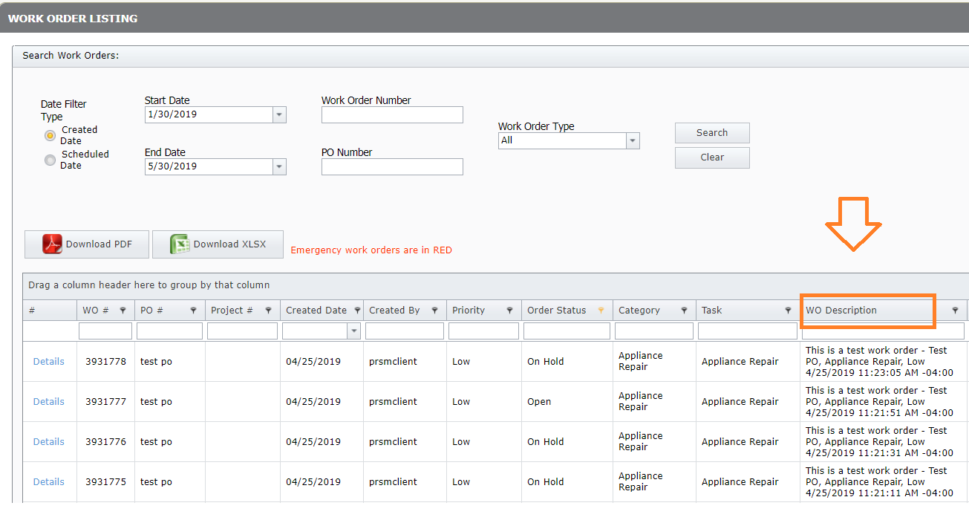
- Grid Column Sequence Optimization

Within each grid, the columns have been grouped together with related data and sequenced in a logical work flow manner to make it more efficient for the user to consume the data. This same logic was then carried over across each page, so a user knows where to consistently look to find a specific field.

Here is the sequence for ‘WO List’:

- WO #, PO #, Project #, Created Date, Created By, Priority, Order Status, Category, Task, WO Description, ISP Name, Scheduled Date, Company, Loc #, District, Region, City, State, Cap Ex, GL Code, Subtotal, Tax, Total, Invoice#

We understand that each user will have their own preference on the grid column sequence that makes them the most efficient, so we are looking into solutions to satisfy this request in a future release.

- Grid Column Size Adjustments

The grid columns width within each page has been adjusted. The goal was to make them as narrow as possible to minimize scroll left to right for the user, but still leaving them wide enough so wrapped text does not exceed 3-4 rows.

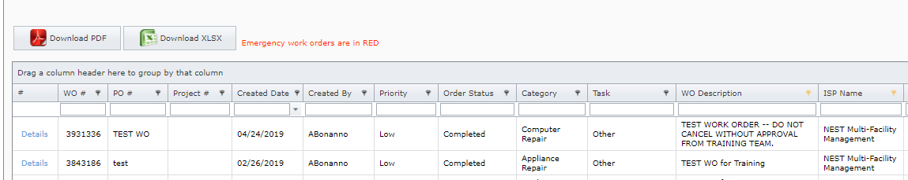

- View Previously Approved and Declined Proposals

The Proposals page has been updated to allow users to view previously Approved and Declined Proposals, in addition to Open which still need reviewed. By default, the page will display Proposals in an Open status, but there has been a dropdown option added so a user can select All, Open, Approved or Declined. Proposal filter deflections are sticky and will be saved throughout the session. For example, if a user filters on Approved it will always filter to Approved until they logout or their session times out.

This feature will be helpful if a user wants to see the details of a previously Approved or Declined Proposal.

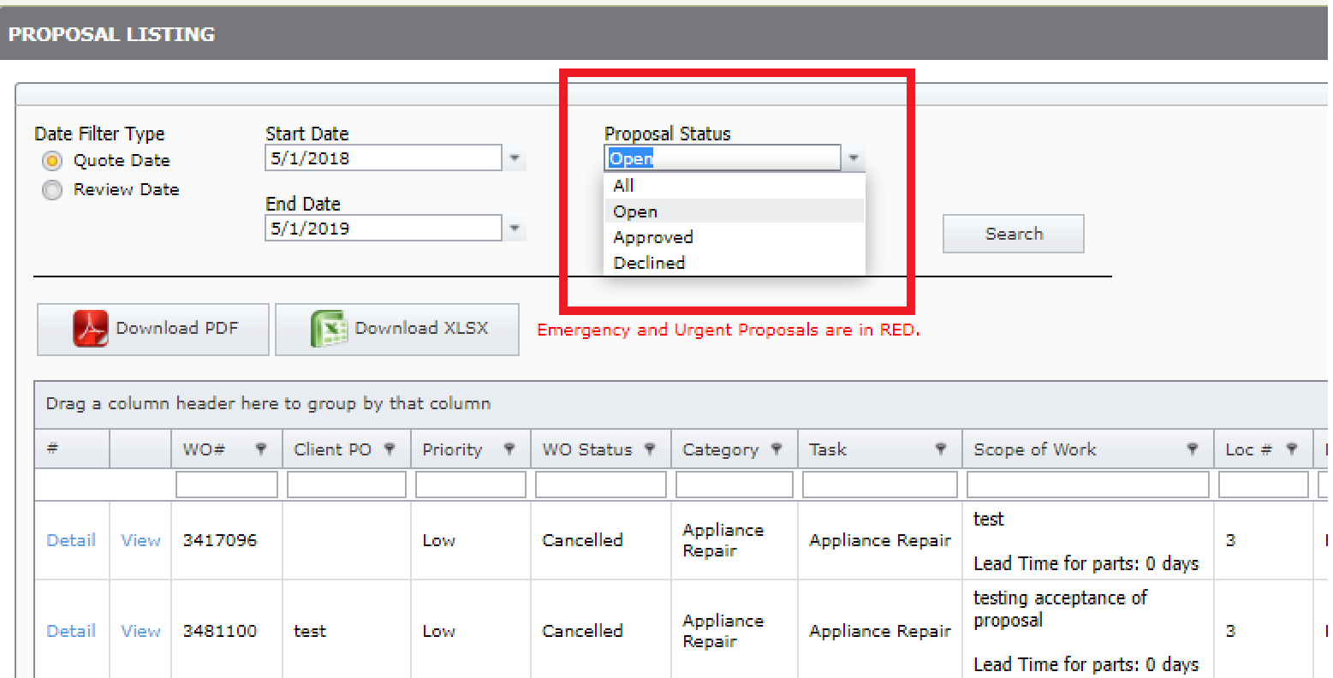

- Search for Proposals by Quote Date or Review Date

The Proposals page has been updated so a user can search for Proposals by Quote Date or Review Date. Quote Date is the date that the Proposal was submitted, and Review Date is when the Proposal was Approved or Declined. The user just needs to Select the Date Filter Type, enter the Start and End Date range and select search to display the Proposals that meet the criteria.

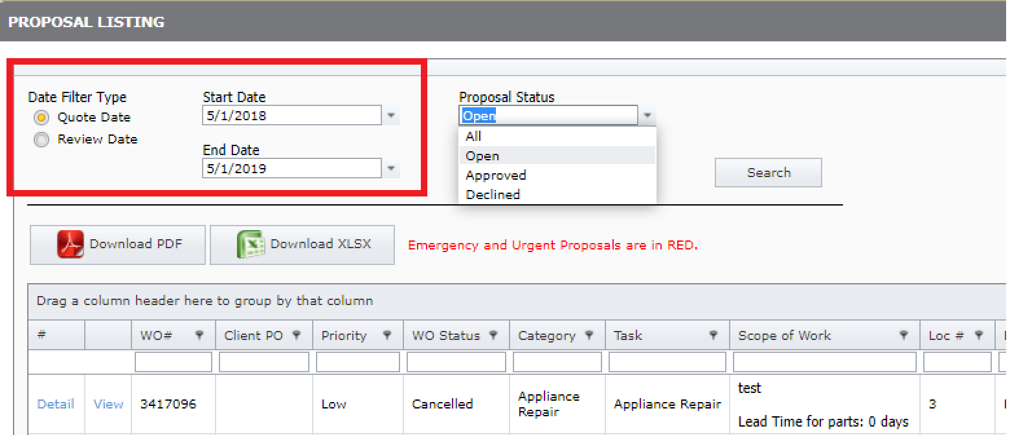

- Simplified Workflow to Approve/Decline Proposals

Modifications have been made to simply the page used to Approve and Decline Proposals. Users now can Approve or Decline from the same page which allows for a more efficient process. If the user selects Approve, they will have 2 optional fields, ‘PO Number’ and ‘Capital Expense’. If they edit either of those fields, the data will save once the ‘Approve’ button is selected. If the user selects ‘Decline’, they also have 2 fields, ‘Decline Reason’, which is Required and ‘Decline Message’ which is optional. This will save when the ‘Decline’ button is selected.

The selection of ‘Cancel’ in either case will return the user to the Proposal Listing page.

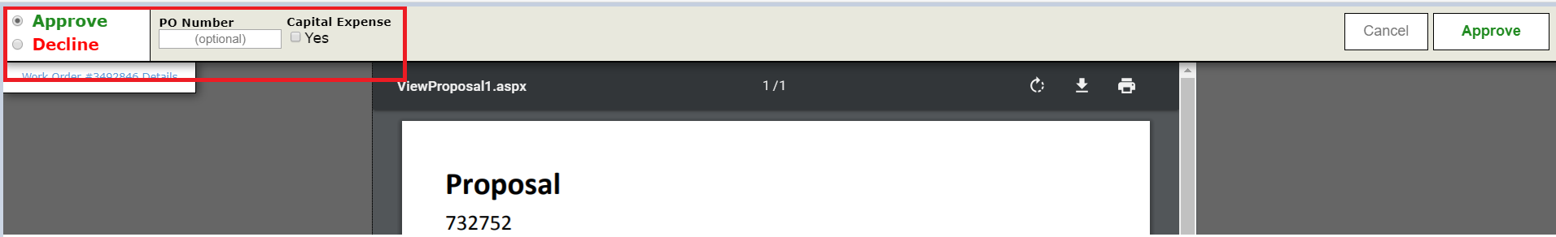

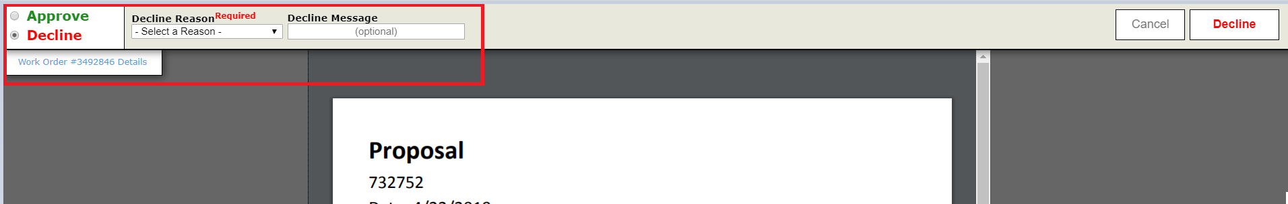

- Mark a Work Order as Capital Expense when Approving Proposals

The ability has been added to mark a work order as Capital Expense when Approving a Proposal. This is will be convenient for users because this is the time when they are determining if the work being performed meets their Capital Expense criteria.

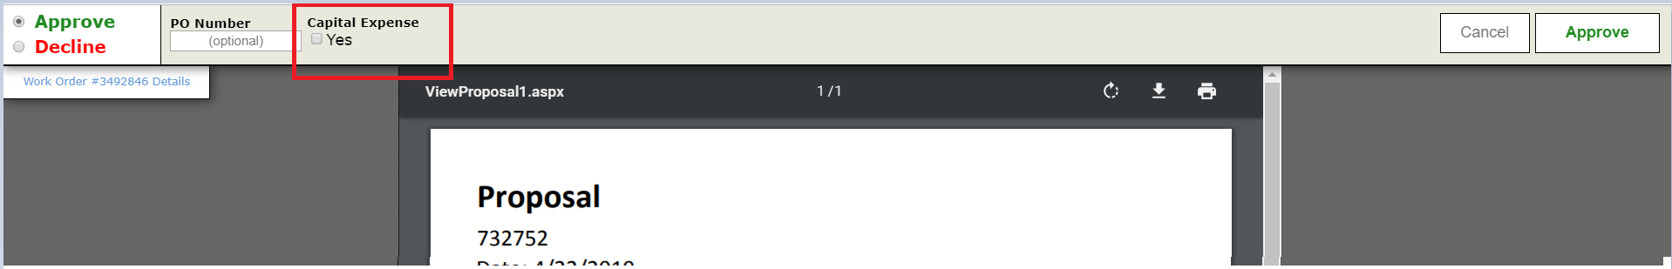

- Ability to Review Work Order Details Without Leaving Proposal Screen

A link has been added to the View Proposal Page that will take the user to a new tab in the browser showing the Work Order Details. This is helpful so the user does not need to exit the Proposal page.

