

Client Portal Release Notes
4/3/19

Features

- Ability to Change Priority for Work Orders Assigned to Client Managed Providers
- Notification Sent when Priority Is Changed
- Ability to Multi-Select Values within Grid Column Filters
- Option to Choose All, Blanks or Non-Blanks on All Grid Column Filters without Multi-Select Ability
- Add Work Order From Location Details Page
- Date Range Removed from Invoice Approval Page
- Performance Enhancement to Home Page

Feature Details

- Ability to Change Priority for Work Orders Assigned to Client Managed Providers
An enhancement has been completed to allow specific users to change the Priority for Work Orders that are assigned to Client Managed Providers. This action can be completed within the ‘Order Details’ of a Work Order from the ‘WO List’ and ‘ In Progress WO’ pages.

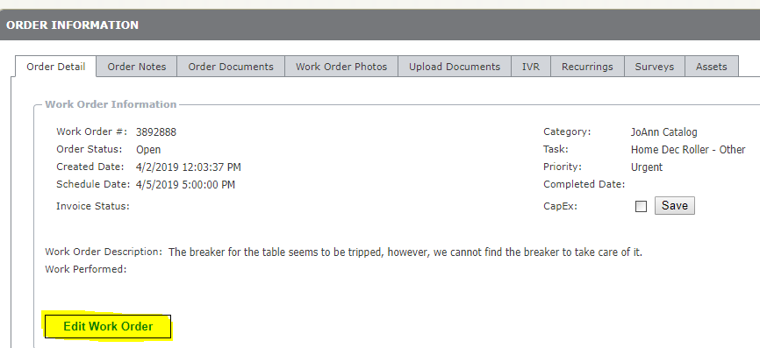
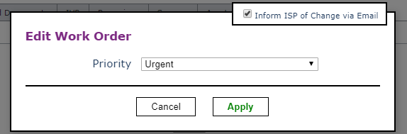

- Notification Sent when Priority Is Changed

From the feature above, when a user changes the priority of a work order, they will have the option to ‘Inform ISP of Change via Email’. This box is checked by default but can be unchecked if desired. If it is checked when the Priority is changed, a Notification will get sent automatically to the email address that is on file for the provider informing them of the change.

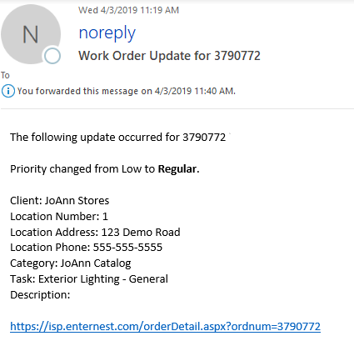

- Ability to Multi-Select Values within Grid Column Filters

An enhancement has been added to Grid Column Filters that allows a user to Select All, 1 or multiple values within the returned data set. This was added for the majority of the columns on all the Client Portal grids with the exception of columns with Dates and WO/PO/Inv/Location Numbers

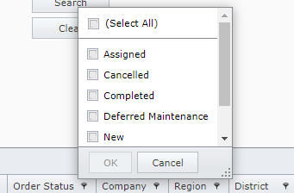

- Option to Choose All, Blanks or Non-Blanks on All Grid Column Filters without Multi-Select Ability

It was identified that there was a few non multi-select grid columns that did not have the option for the user to select All, Blanks or Non-Blanks. These were fixed.

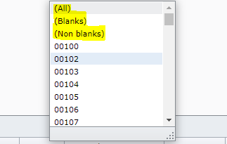

- Add Work Order From Location Details Page

An enhancement was completed to allow a user to Add a New Work Order directly from the Locations page. This is only applicable if the user has access to the Locations page.

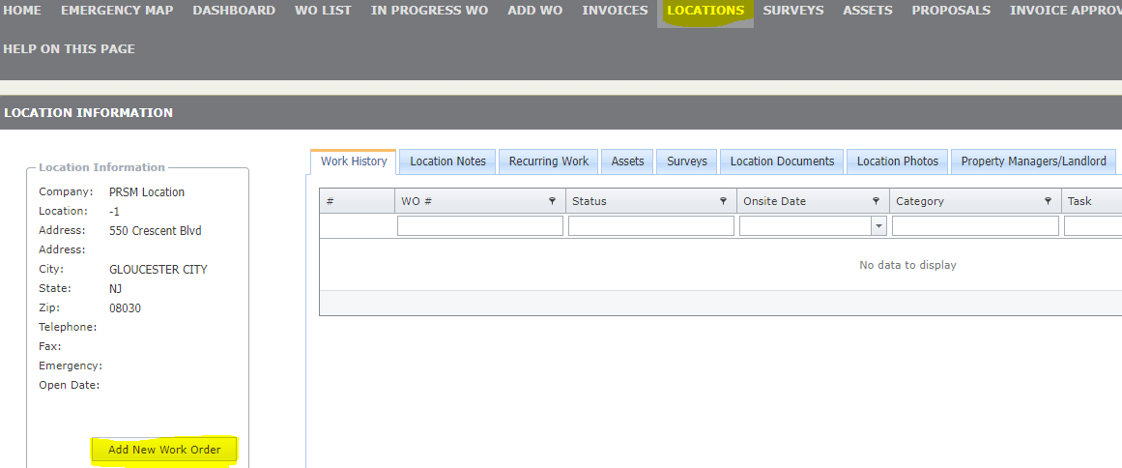

- Date Range Removed from Invoice Approval Page

The Invoice Approval Page has been updated by removing the Date Range filter option. This page will now show all Invoices that are Pending Review regardless of the Invoice Date. This is not applicable if the user does not have access to this page.

- Performance Enhancement to Home Page

Updates were made to the Home Page to make the page load faster.

