

Client Portal Release Notes
2/21/2020

Items

- Wild Card Search
- Grid Height Adjustments (In Progress List & Invoice Listing)
- Displaying Preferred Vendor Invoice # on the Invoices Tab

Item Details

- Wild Card Search

Throughout all tabs where the “WO Description” is an option to filter, the wild card search feature has been turned on. If the word or phrase entered in the “WO Description” are contained anywhere in the description field, those work orders will appear.

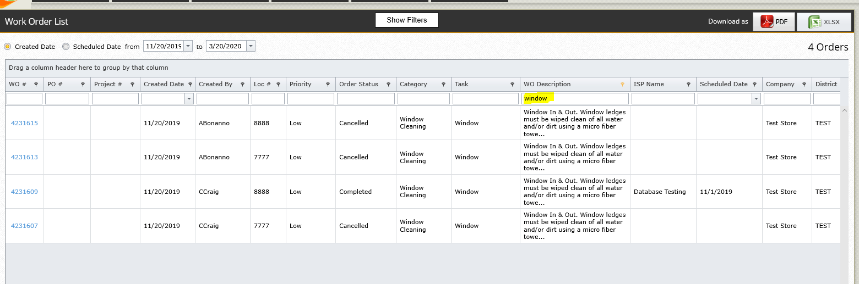

- Grid Height Adjustments (In Progress List & Invoice Listing)
The grid heights have been adjusted to maximize the number of rows a user can view without scrolling. Adjustments to the grid height have been made on the In Progress List & Invoice Listing.

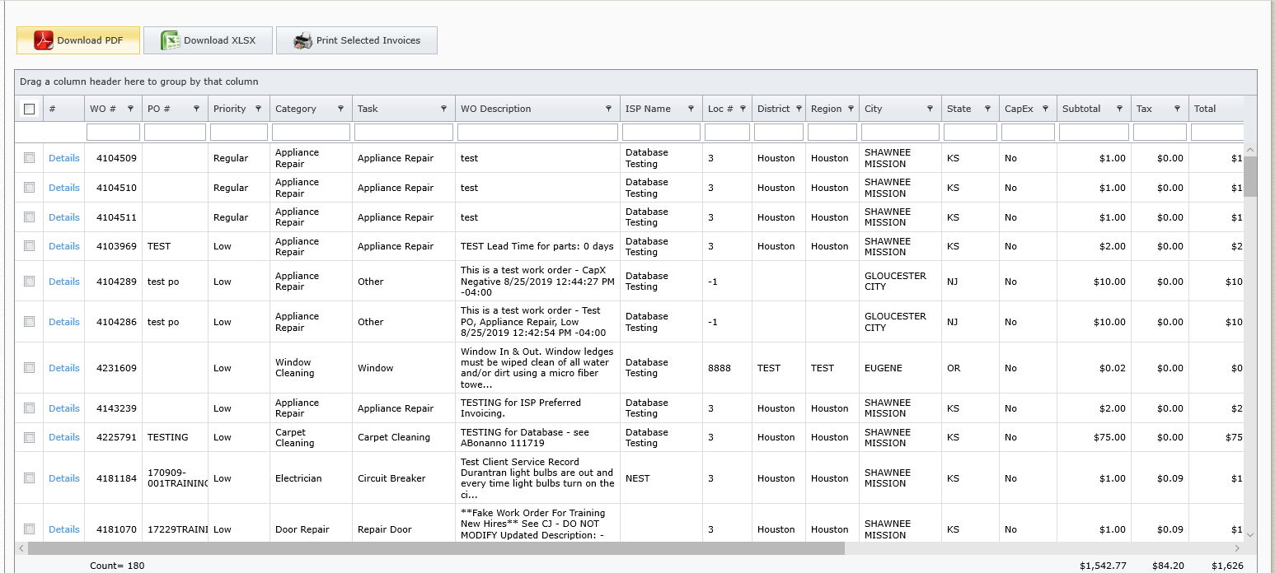

- Displaying Preferred Vendor Invoice # on the Invoices Tab

The Invoices tab will now display the preferred vendor invoice number. If a work order is associated to a preferred vendor, the invoices # column will show the invoice number of the preferred vendor. If there is not a preferred vendor associated to the work order it will show the NEST invoice number. You can also search for the preferred vendor invoice number in the Invoice Number search field.

