

Client Portal Release Notes
2/13/19

Features

- Ability to Email a Note

- Make Location Number a Link to Location Details

- Location Address and Phone Number Added

Feature Details

- Ability to Email a Note

An enhancement has been added to the “Order Notes” section within the Work Order Details that gives a client user the option to email a note to a recipient of their choice.

If the user wants to email the note, the first step is to select the “Email Note” checkbox. Once this is done, the following 3 options appear.

- “Action Required” checkbox – If this option is chosen, the Subject Line in the email that is sent will start with “Action Required”.
- “Email To” – This field can be used if the user wants to manually add an email address to send the note to. This field also auto populates with the email address if the user selects a recipient from the “Pick From a List”. Note that more than 1 email address must be separated by a semicolon.
- “Pick From a List” – When this box is selected, a pre-populated list of recipients will appear that can be selected from. This list will vary depending on the user type (store user vs. non-store user (corp/dm, etc)
  - Store Users
    - Store email address where the service is being completed.
    - Email address for Service Provider performing the work.
    - Any group email addresses.
  - Non-Store Users (Corp / DMs etc)
    - Same options as the Store Users but also specific client users per their request.

Once the user has entered their recipients and added the Note, they would hit the “Save” button and the note will be emailed out in addition to showing in the note history at the bottom of the page.

If the user does not select the “Email Note” checkbox on the top of the page, the note will just populate in the note history at the bottom of the page and no email will get sent out.

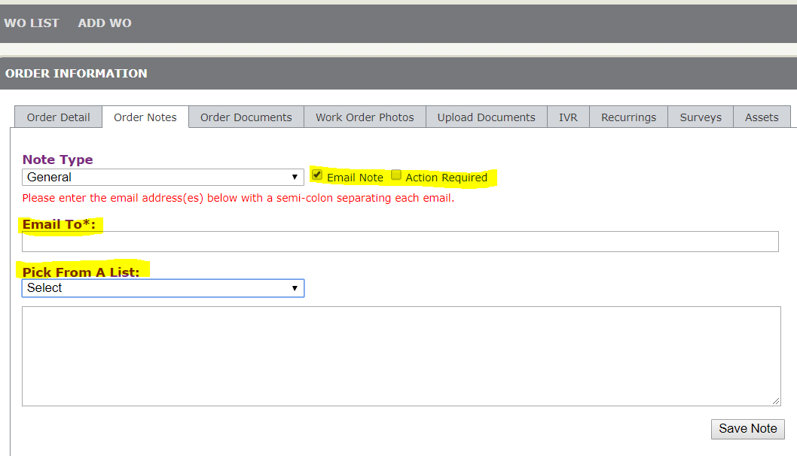

- Make Location Number a Link to Location Details

The Location Number has been turned into a hyperlink to the Location Details page within the ‘Details’ section of the Work Order, Proposal, Invoice, Survey, and Asset

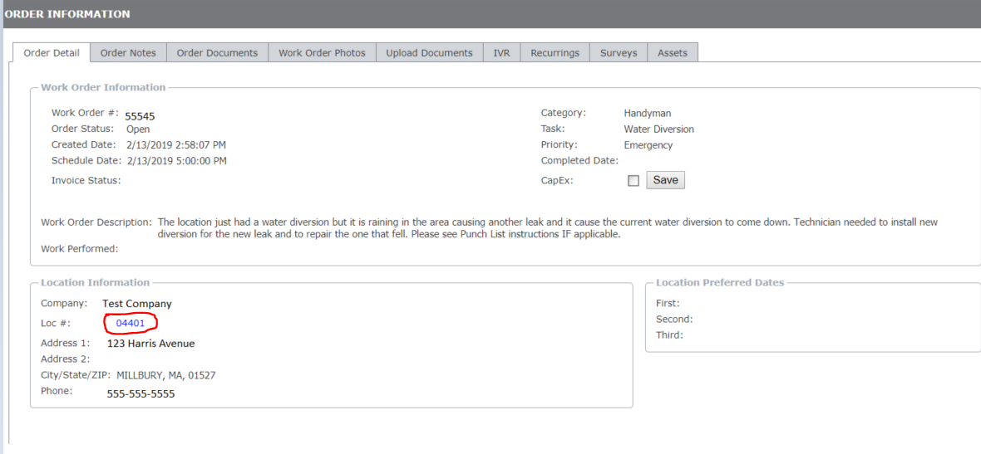

- Location Address and Phone Number Added

The ‘Details’ section of the Work Order, Proposal, Invoice, Survey, and Asset have been updated to show the Locations full address and phone number

