

Client Portal Release Notes
1/7/2020

Items

- Elective Work Column
- Copy to Clipboard Feature
- % of Open Work Orders on Home Page
- Proposal Tab Total Column

Item Details

- Elective Work Column

The Elective Work Column is now visible in the Proposals Tab.

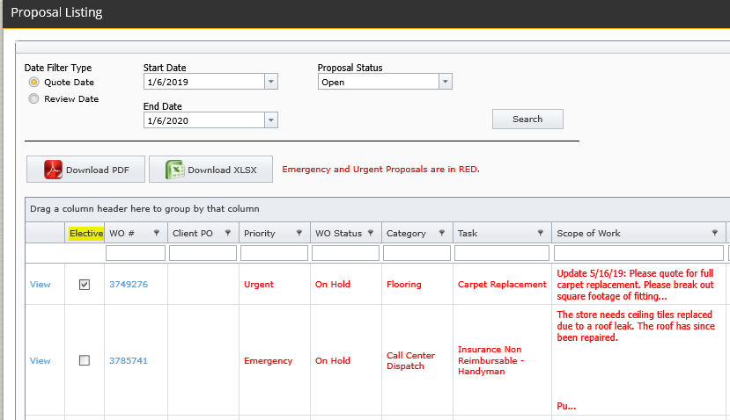

- Copy to Clipboard Feature

The Copy to Clipboard feature is available on the Work Order Details screen and now works in Microsoft browsers. From here, you can copy the Description of Work.

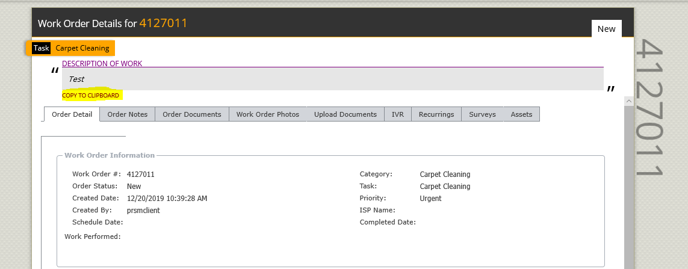

- % of Open Work Orders on Home Page
The Percent of Open Work Orders on the home page will now display No Data when there are no work orders within those time buckets. Remember you can change your filters by selecting “Show Filters” to produce more results.

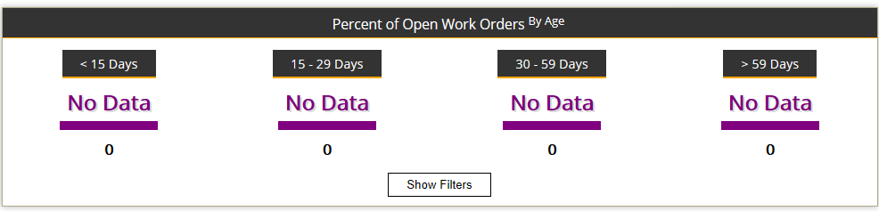

- Proposal Tab Total Column

An update was made to the Proposal Tab Total Column to show proper dollar formatting.

