

Client Portal Release Notes
8/16/19

Enhancements

- Upload Documents - Update to ‘Upload Documents’ Page to allow for ‘Document Type’
- Capital Initiative - Ability to Associate a Work Order to a Capital Initiative
- Capital Initiative – Increased allowable Character Count for Name and Number to 75
- Capital Initiative – Added Red Asterisks Next to Required Fields and Dialog Box if Required Fields Not Filled Out.
- Schedule Date/ISP Name Display – Update to Logic on how this Displays within Grids and Order Details.
- Email Alerts – New Work Order Alert Emails were Disabled for a few Clients

Enhancement Details

- Upload Documents - Update to ‘Upload Documents’ Page to allow for ‘Document Type’

The ‘Upload Documents’ page was updated to now allow for a user to select a ‘Document Type’ for the attachment they are uploading. This allows for attachment to be viewable instantly after upload. Prior to this, the attachment would require review from a NEST associate prior to the Client user being able to see it. The user first must select the ‘Document Type’ from the dropdown, select ‘Browse’ to find the file and hit upload. Then go to in the ‘Order Documents’ or ‘Work Order Photos’ page depending on the documents type chosen to review it.

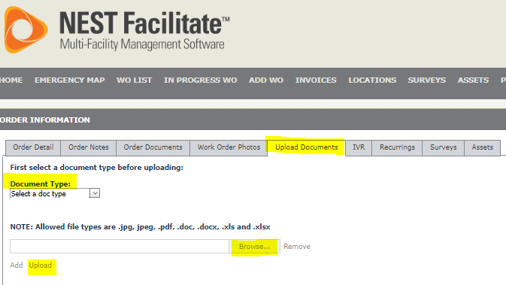

- Capital Initiative - Ability to Associate a Work Order to a Capital Initiative

Functionality was added For Clients that have the Capital Initiative feature. They can now associate a work order to a Capital Initiative.

Within the ‘Order Detail’ page for work orders that don’t have an Approved Invoice, the user is given the Capital Initiative option when they select the ‘CapEx’ checkbox. The Capital Initiative dropdown is prepopulated with the list of Capital Initiatives that were setup for that specific client. After one is selected, the Capital Initiative # will automatically populate and the user can select ‘Save’.

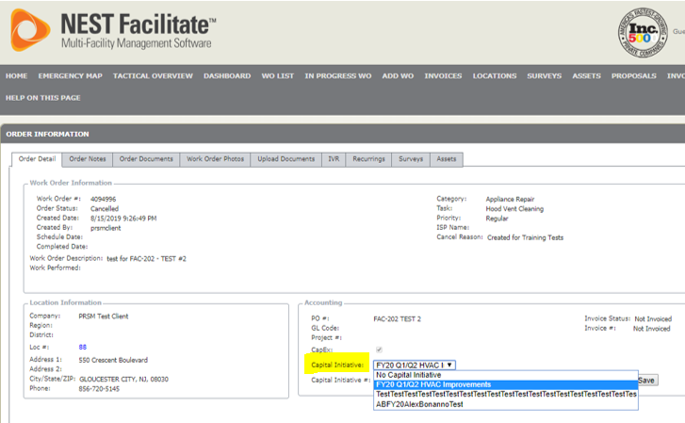
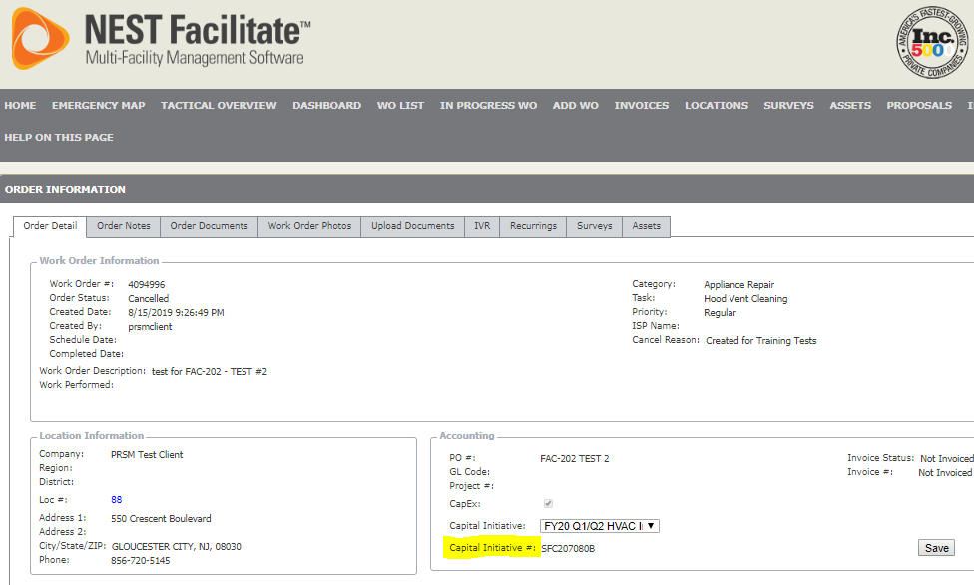

- Capital Initiative – Increased allowable Character Count for Name and Number to 75

Client users that have permission to create Capital Initiatives, now can use up to 75 Characters for Name and Number. This was previously set to 50.

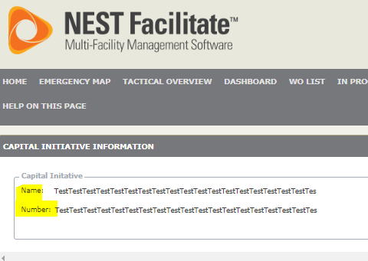

- Capital Initiative – Added Red Asterisks Next to Required Fields and Dialog Box if Required Fields Not Filled Out.

On the ‘Add New Capital Initiative’ Page, Red asterisks were added for required fields.

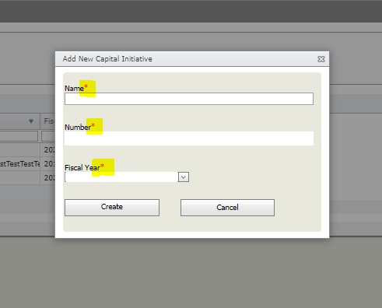

If required fields are not filled out, a dialog box will appear informing the user

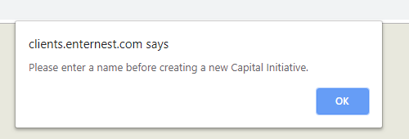

- Schedule Date/ISP Name Display – Update to Logic on how this Displays within Grids and Order Details.

The logic has been updated for how the UI displays Schedule Date and ISP Name if a work order has more than 1 of each.

If a work order has more than 1 active Service Provider assigned to the work order, the UI will display the most recently added Service Providers. If that Service Provider has more than 1 Schedule Date, the UI will show the Schedule date that is closest to current date as long as it is not in the past. If none of the schedule dates are in the future, it will show the most recent in the past.

- Email Alerts – New Work Order Alert Emails were Disabled for a few Clients

The email alerts that are sent when a work order gets created on the Client Portal and go to service@enternest.com have been disabled for JOANN, Sally Beauty and Five Below.

